Code:

import io

import json

import torch

import wandb

from models.CreditFraudNetMLP import CreditFraudNetMLP

from pandas import DataFrame

from torch import nn

from torch.utils.data import DataLoader, TensorDataset

class ExampleTorchModal:

    def __init__(self, features, dataset_path, epochs=1, lr=0.3) -> None:

        self.epoch = epochs

        self.features = features

        self.lr = lr

        self.dataset_path = dataset_path

        if torch.cuda.is_available():

            device = torch.device("cuda")

        else:

            device = torch.device("cpu")

        self.device = torch.device(device)

        # Initialize the dataset

        self.init_dataset(self.dataset_path)

        # Weights & Biases

        wandb.init(project="Credit_Card_Flock")

    def init_dataset(self, dataset_path: str) -> None:

        self.dataset_path = dataset_path

        with open(dataset_path, "r") as f:

            dataset = json.load(f)

        dataset_df = DataFrame.from_records(dataset)

        batch_size = 128

        X_df = dataset_df.iloc[:, :-1]

        y_df = dataset_df.iloc[:, -1]

        X_tensor = torch.tensor(X_df.values, dtype=torch.float32)

        y_tensor = torch.tensor(y_df.values, dtype=torch.float32)

        y_tensor = y_tensor.unsqueeze(1)

        dataframe_in_dataset = TensorDataset(X_tensor, y_tensor)

        self.train_data_loader = DataLoader(

            dataframe_in_dataset,

            batch_size=batch_size,

            shuffle=True,

            drop_last=True,

        )

        self.test_data_loader = DataLoader(

            dataframe_in_dataset,

            batch_size=batch_size,

            shuffle=True,

            drop_last=False,

        )

    def train(self, parameters=None) -> bytes:

        model = CreditFraudNetMLP(self.features, 1)

        if parameters is not None:

            model.load_state_dict(torch.load(io.BytesIO(parameters)))

        model.train()

        optimizer = torch.optim.SGD(model.parameters(), lr=self.lr)

        criterion = nn.BCELoss()

        model.to(self.device)

        for epoch in range(1, self.epoch + 1):

            train_loss = 0.0

            train_correct = 0

            train_total = 0

            for inputs, targets in self.train_data_loader:

                optimizer.zero_grad()

                inputs, targets = inputs.to(self.device), targets.to(self.device)

                outputs = model(inputs)

                loss = criterion(outputs, targets)

                loss.backward()

                optimizer.step()

                train_loss += loss.item() * inputs.size(0)

                predicted = torch.round(outputs).squeeze()

                train_total += targets.size(0)

                train_correct += (predicted == targets.squeeze()).sum().item()

            wandb.log(

                {

                    "epoch": epoch,

                    "loss": train_loss / train_total,

                    "accuracy": train_correct / train_total,

                }

            )

        buffer = io.BytesIO()

        torch.save(model.state_dict(), buffer)

        return buffer.getvalue()

    def evaluate(self, parameters) -> float:

        criterion = nn.BCELoss()

        model = CreditFraudNetMLP(self.features, 1)

        if parameters is not None:

            model.load_state_dict(torch.load(io.BytesIO(parameters)))

        model.to(self.device)

        model.eval()

        test_loss = 0.0

        test_correct = 0

        test_total = 0

        with torch.no_grad():

            for inputs, targets in self.test_data_loader:

                inputs, targets = inputs.to(self.device), targets.to(self.device)

                outputs = model(inputs)

                loss = criterion(outputs, targets)

                test_loss += loss.item() * inputs.size(0)

                predicted = torch.round(outputs).squeeze()

                test_total += targets.size(0)

                test_correct += (predicted == targets.squeeze()).sum().item()

        accuracy = test_correct / test_total

        return accuracy

    def aggregate(self, parameters_list) -> bytes:

        parameters_list = [

            torch.load(io.BytesIO(parameters)) for parameters in parameters_list

        ]

        averaged_parames_template = parameters_list[0]

        for k in averaged_parames_template.keys():

            temp_w = []

            for local_w in parameters_list:

                temp_w.append(local_w[k])

            averaged_parames_template[k] = sum(temp_w) / len(temp_w)

        buffer = io.BytesIO()

        torch.save(averaged_parames_template, buffer)

        aggregated_parameters = buffer.getvalue()

        return aggregated_parameters

if __name__ == "__main__":

    epochs = 10

    lr = 0.000001

    features = 30

    dataset_path = "data/creditCard.json"

    model = ExampleTorchModal(features, dataset_path, epochs=epochs, lr=lr)

    # Training the model

    trained_parameters = model.train()

    # Evaluating the model

    accuracy = model.evaluate(trained_parameters)

    print(f"Model accuracy: {accuracy * 100:.2f}%")

    # For aggregation example, you need a list of parameters from different training sessions

    # Since we don't have multiple sessions, we'll simulate it with the same parameters

    parameters_list = [trained_parameters, trained_parameters]  # Example list

    aggregated_parameters = model.aggregate(parameters_list)

    # Re-evaluate the aggregated parameters

    aggregated_accuracy = model.evaluate(aggregated_parameters)

    print(f"Aggregated model accuracy: {aggregated_accuracy * 100:.2f}%")

Results:

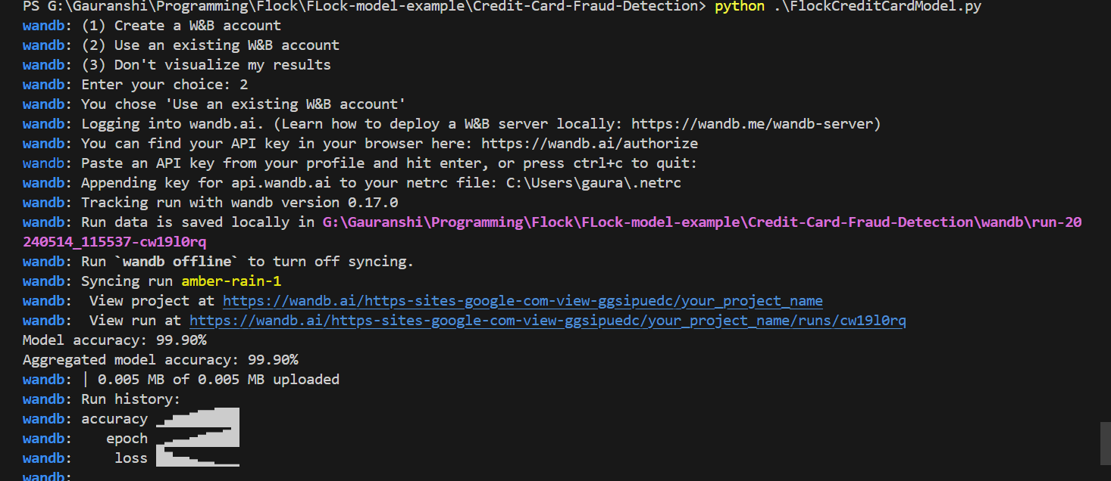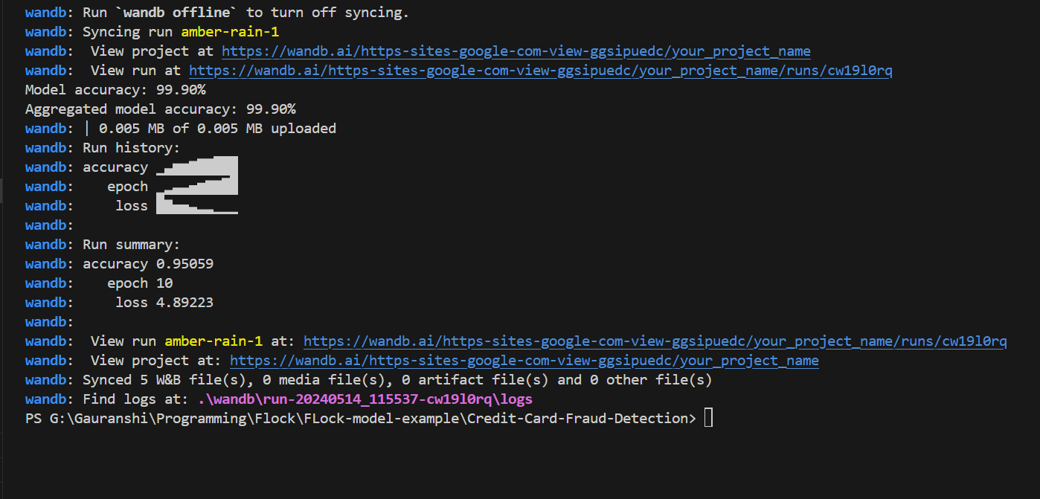

For 10 epochs: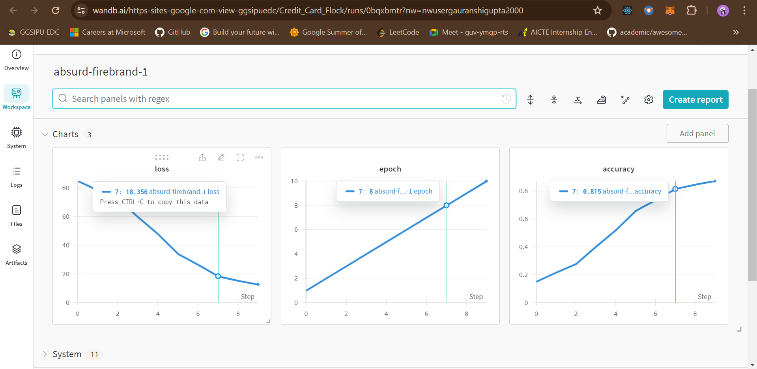

For 100 epochs:

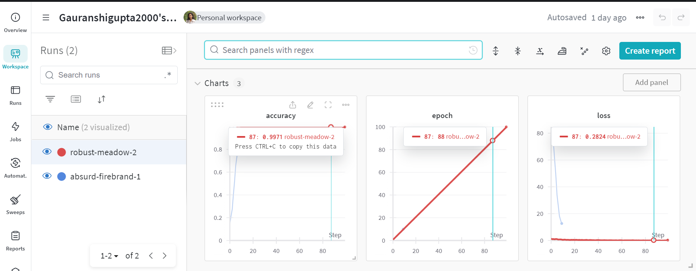

Report Link:

<https://api.wandb.ai/links/https-sites-google-com-view-ggsipuedc/ef9jcitu>